# Department of Computing

**CS344: Web Engineering**

**Class: BESE – 4AB**

# Lab 1: HTML 5 Introduction

**Date: September 15, 2015**

**Time: 10:00 AM to 01:00 PM**

# Instructor: Mr. Fahad Ahmed Satti

# 

# Lab 1: HTML 5 Introduction

**Introduction**

In this lab, students will extend / update the HTML 5 skeleton page and create their own portfolio using HTML 5. Each student must, individually build the complete application on their own. Students must make sure their webpages are working properly and within defined constraints and will use [GitHub](http://www.github.com) to manage their solutions.

**Objectives**

The objective of this lab is to understand basics of HTML 5 tags and how to use it in your web pages or websites and managing a version control system (VCS) to control their solutions.

**Tools/Software Requirement**

* Notepad / Notepad ++
* Github and LMS

**Description**

For creating webpages through HTML you will be required to follow the following steps.

* Open Notepad and start your HTML tags/code.

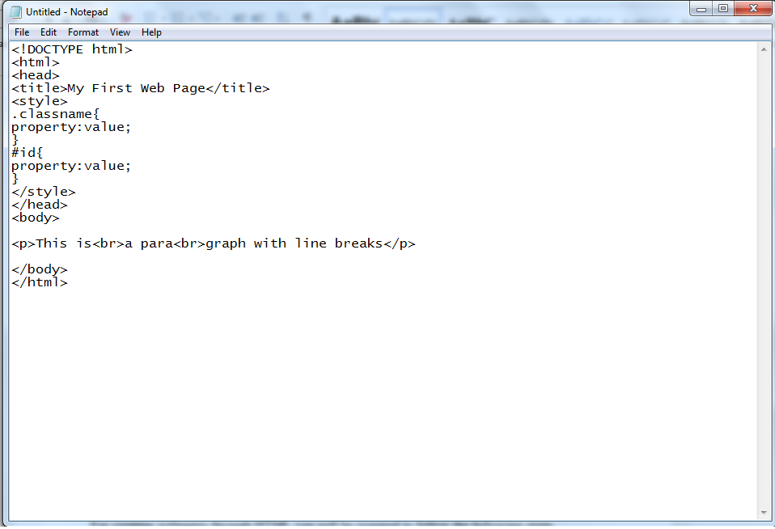

* Save your text file with .html extension.

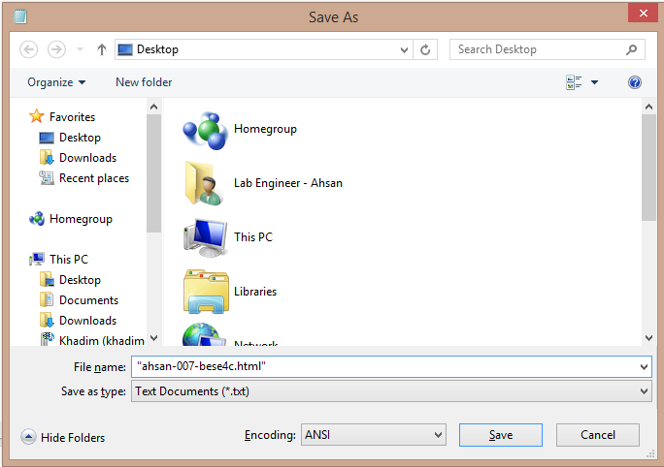

* Double click the file saved and you will see your webpage in a browser.

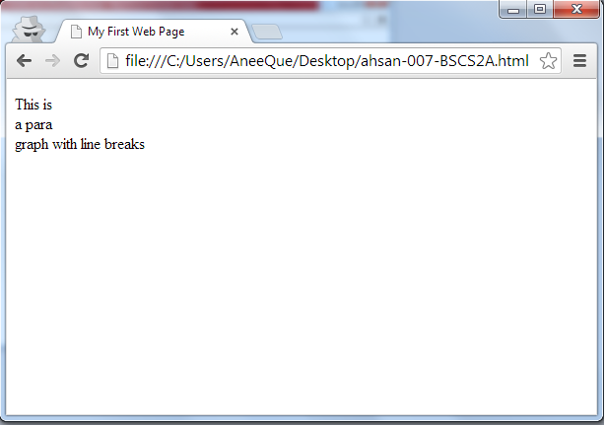

## Pitfalls

* Any exceptions or errors leading to non-execution of submitted code.
* Failure to upload the solution to GitHub or not sharing the public repo link on LMS.
* Failure to maintain scoring
* Failure to automate the enemies or respond correctly to the user input.

**Lab Tasks**

* Update the skeleton HTML5 page and create your own portfolio.
* Pages: Home, About, Gallery, Contact Me

**Deliverables**

Students must upload their solutions on GitHub and then share the following on LMS:

1. Description document
2. All source code
3. Link to public repo hosting the code

This lab is graded. Min marks: 0. Max marks: 10.